UniChat - Everything You Need

Phase 3 Report - Final Report and Presentation



Group 06

Igor Diniz - UP 202000162

João Pinheiro - UP 202008133

Ricardo Cavalheiro - UP 202005103

**Project Description** **4**

**Related apps, services or systems** **4**

**Questionnaire Highlights** **4**

**Answers to 11 questions** **5**

Who are the users? 5

What tasks do they perform? 5

What tasks are desirable? 5

How are tasks learned? 5

Where are tasks performed? 6

What is the relationship between the user and information? 6

What other instruments does the user have? 6

How do users communicate? 6

How often tasks are performed? 6

Are there time restrictions? 6

What happens if something goes wrong? 6

**Personas** **8**

**Activity Scenarios** **10**

1. João Lopes 10

2. Diana Lopes 10

**Simplified Conceptual Model** **11**

● Objects (attributes) 11

● Actions 11

● Relations between 11

**Functionalities and tasks** **12**

**The app should enable the user to:** **12**

**Usability Requirements** **13**

**Main Takeaways (Phase 1)** **14**

**Prototype’s Wireflow (Phase 2)** **15**

● Send a message and start a video call 15

● Show interest in an event 16

● Access the forum 16

● Search for messages and contacts 17

**Heuristic Evaluation Results** **17**

**Corrections to perform in Phase 3** **18**

**Main Takeaways (Phase 2)** **19**

**Final Prototype’s Wireflow** **20**

1. Send a message 20

2. Show interest in an event 20

3. Search for query in messages 21

**Evaluation Protocol** **22**

Objective 22

Users 22

Method 22

Tasks 23

Measures 23

Data being collected 23

User Profiling 23

Task relative 23

Satisfaction 23

**Results and statistical analysis** **24**

**Conclusions** **26**

**Annexes** **27**

Questionnaires 27

Figure 5. Adaption difficulty 27

Figure 6. Success of academic cycle 27

Figure 7. Satisfaction with the course 28

Figure 8. What to do after finishing the bachelor 28

Figure 9. Social media usage 28

Figure 10. Adaptability of a new social media 29

Figure 11. Impact of social media 29

Received Heuristic Evaluation Reports 30

Group 5: Heuristic Evaluation of Group 5 30

Group 7: Heuristic Evaluation of Group 7 31

Statistics 32

Figure 12. Users interviewed 32

Figure 13. Users responses on what most important on a university community app 32

Figure 14. Task 1 data collected 33

Figure 15. Task 2 data collected 34

Figure 16. Task 3 data collected 35

# Project Description

The goal of our project is to create an application designed to make it easier for students to communicate among them giving them a better academic experience.

Users must first authenticate using their sigarra account information. The platform will have different rooms that students are divided into based on their subjects which allows students of the same class to get to know each other and to talk about specific subject information such as the division of students into group projects or to discuss topics learned in class.

Users can also view other students’ details in particular age, year of graduation, nationality, and region. Our goal is to create a better environment for every student.

Our goal is to create a better environment for every student.

# Related apps, services or systems

There are some apps and systems that wrap some features described in the above section, for instance:



1. Whatsapp
2. Messenger
3. Agenda Cultural do Porto
4. Discord

# Questionnaire Highlights

From the responses to the questionnaire, we were able to identify the following insights:

1. 52.2% of students had problems with the initial adjustment to college.
2. 52.2% of students are not entirely satisfied with their academic cycle so far.
3. 21.7% of students are not sure if they are in the right course for them or are considering changing areas.
4. 26.1% of students do not have a clear idea of ​​what to do after finishing the current cycle of studies.
5. 70% of students use social media more than 3 hours per day.
6. The social media most used by students are Instagram, Youtube, Whatsapp, Tiktok, and Twitter.
7. 78.3% of students have no difficulty adapting to new social media.
8. What bothers students most on social media are unverified offensive comments
9. 65.2% of students think that social media has been a great benefit in people's lives.

# Answers to 11 questions

## Who are the users?

Our customers are students, from Porto University, with an age gap of 18-23. These students got their adolescence marked by the covid and now face the consequences. They belong to a generation that is destined to thrive.

## What tasks do they perform?

Our users are very talented. From sports to student associations, from academic groups to organizing school trips. A few minorities also work while studying and most of them want to still study after finishing their bachelor's degree.

## What tasks are desirable?

Many students complain about offensive comments on social media. So, it would be ideal to have a way for the student to block or delete comments of this type. In addition, a large percentage of students feel undecided about what to do after graduation. Therefore, it would be interesting to have a place to discuss ideas and suggestions within our application, so that some could help each other with tips, like a forum. Students also will be able to create groups on the platform, talk with each other by text messenger or by video call, and attach/detach groups.

## How are tasks learned?

As our project should focus on the users and their usability, and most of the users are young students who have no problems with the adaptability of a new social media, the tasks would be learned by the experience using the platform. They will be intuitive to learn but will have a guide for beginners when the user accesses the platform at first. Therefore, no previous knowledge is required.

## Where are tasks performed?

A technology device with an internet connection is the only tool a customer needs to use our product.

## What is the relationship between the user and information?

One of the biggest goals of the project is to help the students to have access to useful information, in the academic field. So, sharing information is extremely important to engage the community of students. Students can see personal information about other students, such as age, year of graduation, nationality, and region. Although, confidential information will never be shared, without the consent of the user. There will be a channel where students are going to be able to share information regarding what to do after finishing their cycle of studies.

## 

## What other instruments does the user have?

Nothing, so far.

## How do users communicate?

Users will be chatting through our dedicated chatting tab. There will be group chats divided by year, class, curricular unit, and personalized groups by the user.

## How often tasks are performed?

* Video meeting to discuss academic projects - OFTEN
* Chat with the classroom - ALWAYS
* Share interesting information (like a forum) - OFTEN
* Divide students into groups - OFTEN
* Block messages - HARDLY EVER

## Are there time restrictions?

Users are allowed to use our app at any time they want. It should be available 24h a day.

## What happens if something goes wrong?

Students can send an email to the tech support responsible for the maintainability of the platform.

# Personas

Two personas were created based on the responses to the questionnaire.

The first one is João Lopes, a 25 years old working student from Porto who enjoys socializing and is optimistic about his future.

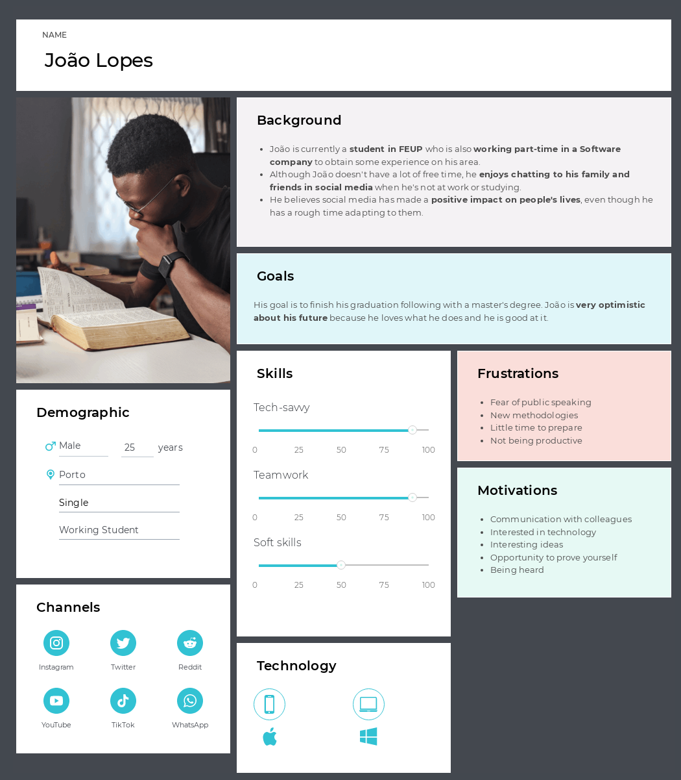

The second one is Diana Lopes

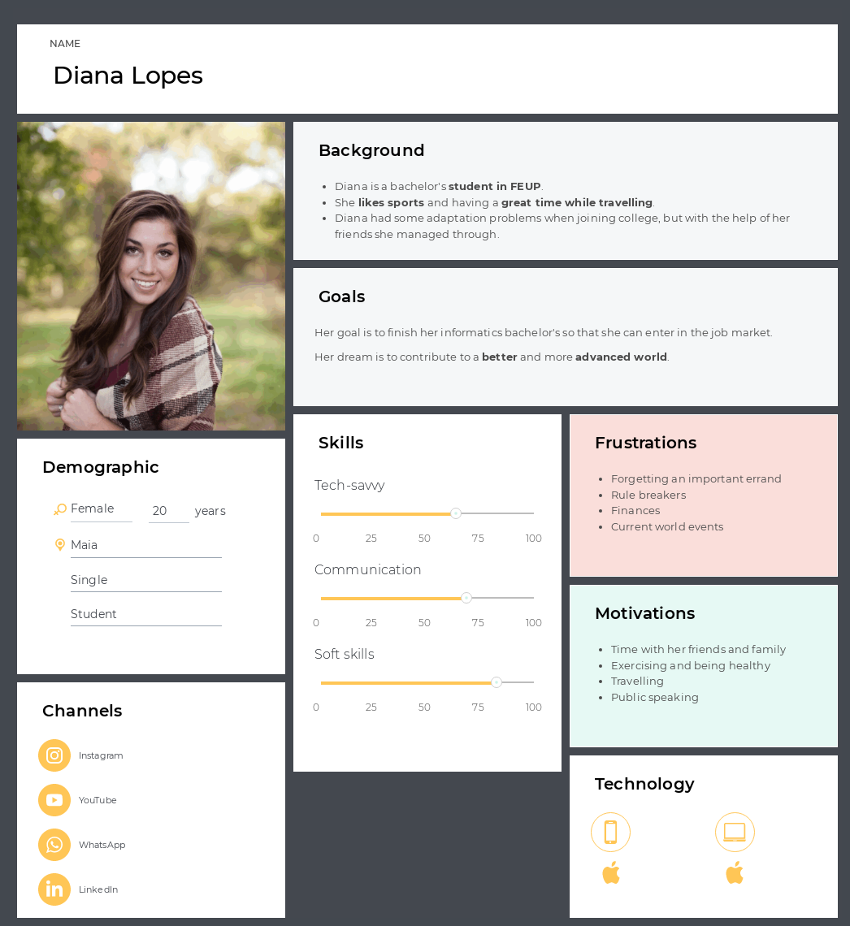

# Activity Scenarios

After getting responses from the questionnaires and identifying the two main personas, we created two different activities whose descriptions are the following:

## João Lopes

João is just preparing for the start of the new academic year. When preparing his backpack, João grabbed his phone to check what he needed for the next day in class. He wasn’t sure about the material so he wanted to chat with his colleagues. He opened **UniChat**, authenticated with his sigarra log-in, and went to the 2nd year group chat. There he sent a message asking what classes they would have the next day and the material needed.

A colleague, Gustavo, answered him with a photo of his backpack full of the material needed for the next day. João reacted with an emoji and went to prepare his backpack to start the semester.

## 2. Diana Lopes

Diana just arrived home after a long and rough day at university. After realizing that she was confused about the topics learned in class she decided to open **UniChat** and talk to her colleagues hoping someone would clarify the subject. Several students also expressed some doubts about it. Lara, who was very attentive in class, managed to explain and clarify with her colleagues about the topics and everyone was grateful. They recognized that with mutual help the academic experience is much more enjoyable and easier.

# 

# 

# 

# 

# Simplified Conceptual Model

## Objects (attributes)

* + User (name, nationality, region, age, role)
    - role = student | teacher
  + message (date, sender, type)
    - type = photo | document | text
  + group chat (date of creation, users)
  + video call (date, duration, users)
  + event (local, date)
  + archive (group)

## Actions

* + Send, edit, remove message
  + join, leave, cre;ate, share group chat
  + archive and unarchive group chat
  + start, join, end video call
  + edit, remove profile information
  + create, edit, remove, show interest in event
  + view other users information

## Relations between

* + User can send messages
  + messages have one author
  + group chat has users
  + group chat has messages
  + video call involves 2 or more users
  + an event has interested users
  + users can be interested in events
  + the archive has group chats

# 

# 

# 

# 

# Functionalities and tasks

# The app should enable the user to:

* Logging in
* Manage message
  + Send text message
  + Send image
  + Send file
  + Edit message
  + Delete message
* Search
  + For messages
  + For colleagues
* Sharing
  + Invite people to group chat
  + Invite people to an event
* Interaction between users
  + Video calls
  + Answering to messages
  + Reacting to messages
* Manage events
  + Create
  + Edit information
  + Remove
  + Show interest in
* Manage group chat
  + Create group chat
  + Add members
  + Remove members
  + Archive group chat

# 

# 

# Usability Requirements

* **Send a text message to a colleague**
  + **Efficacy:**

All users completed the task, 95% didn't make more than 2 errors.

* + **Efficiency:**

Average time under 40 seconds, 90% made less than 25 clicks

* + **Satisfaction:**

Below 2% dissatisfied, 98% preferred our solution.

* **Search for messages and contacts**
  + **Efficacy:**

All users completed the task without any hint, 90% made less than 3 errors.

* + **Efficiency:**

Average time under 30 seconds, the task was completed in less than 10 clicks.

* + **Satisfaction:**

Intuitive task, users showed ease in completing the task.

* **Show interest in event**
  + **Efficacy:**

Users completed the task, 80% made less than 2 errors.

* + **Efficiency:**

Average time under 1 minute, task completed with an average of 10 clicks.

.**Satisfaction:**

The task was easy to learn and complete.

# 

# 

# 

# 

# 

# Main Takeaways (Phase 1)

We realized through research that our app would be useful for FEUP students, mainly in the initial adaptation phase, which is the most difficult period for them.

Other than that, after analyzing the survey, we can expect ease of use of our application, as it will be intuitive like the other social media that students have already used.

Finally, UniChat would also be important for students who are attending the latest year of the studying cycle to discuss the possibilities of what may be done after the degree or master's degree, since the research has shown a significant amount of undecided.

# Prototype’s Wireflow (Phase 2)

## [Send a message and start a video call](https://youtube.com/shorts/n57EBaLJbJo)

# 

## [Show interest in an event](https://youtube.com/shorts/IKIsl3wz0mc)

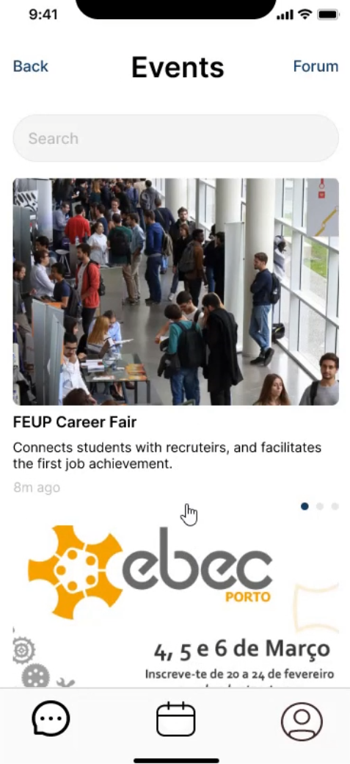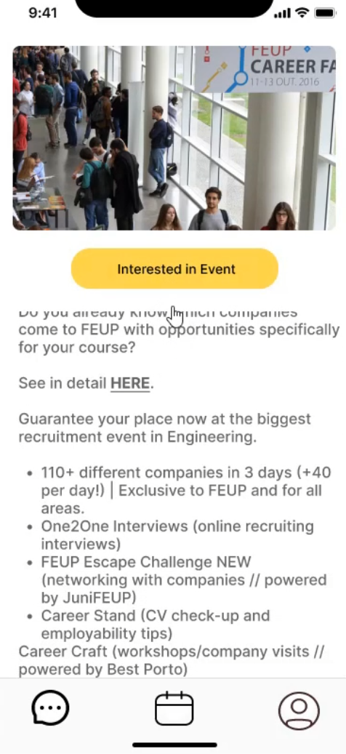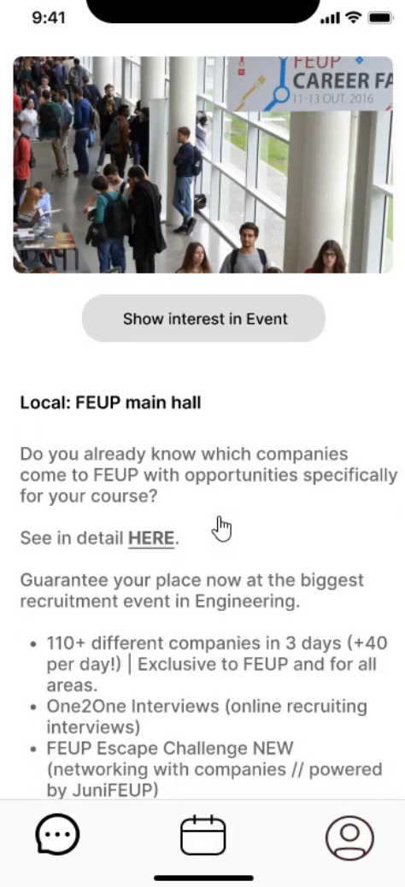



## [Access the forum](https://youtube.com/shorts/TFDf2OnzRII)

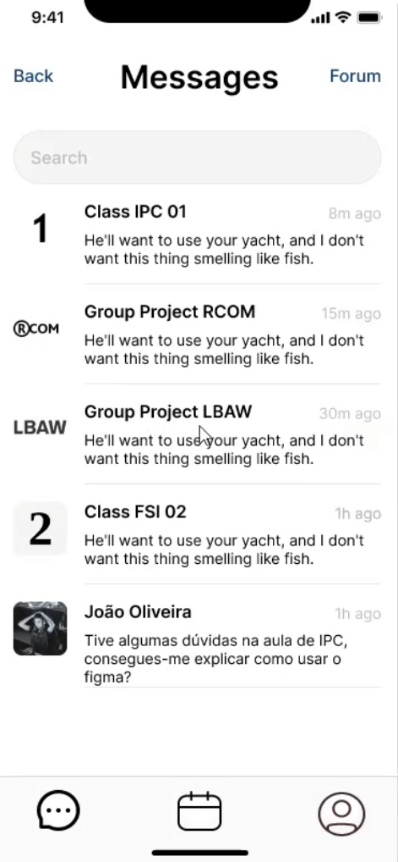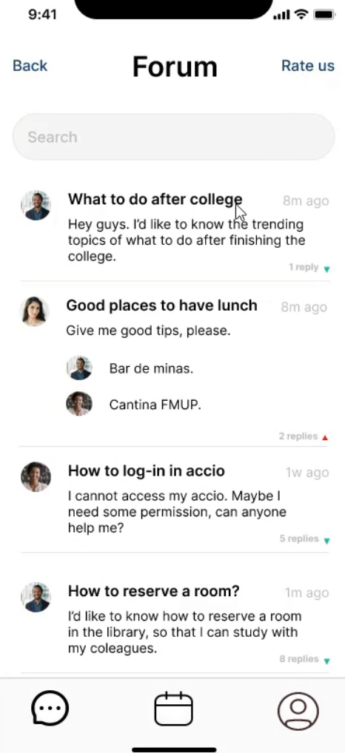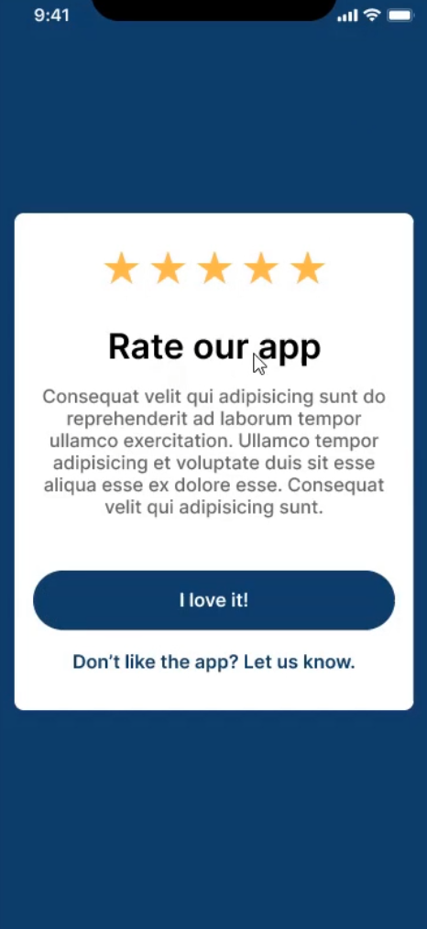





## [Search for messages and contacts](https://youtube.com/shorts/jvWXj3tS4dk)

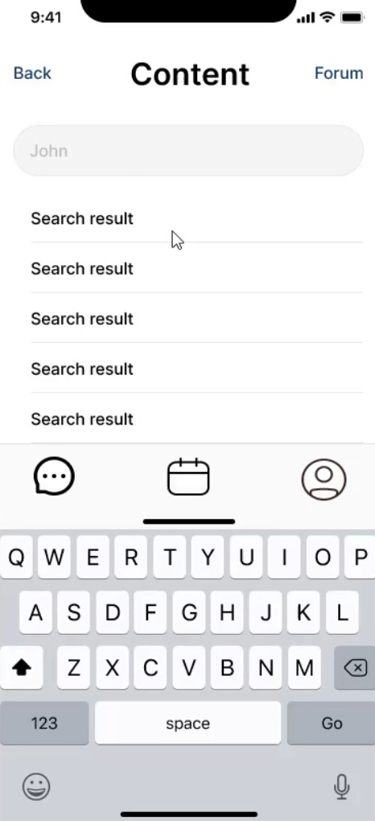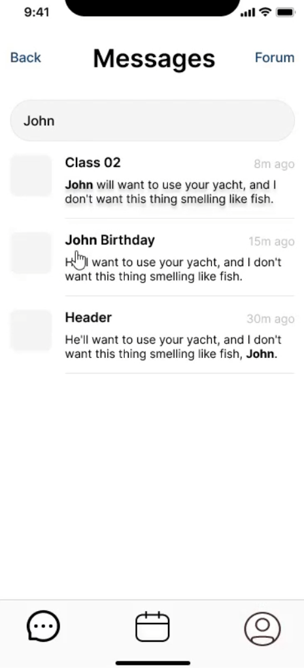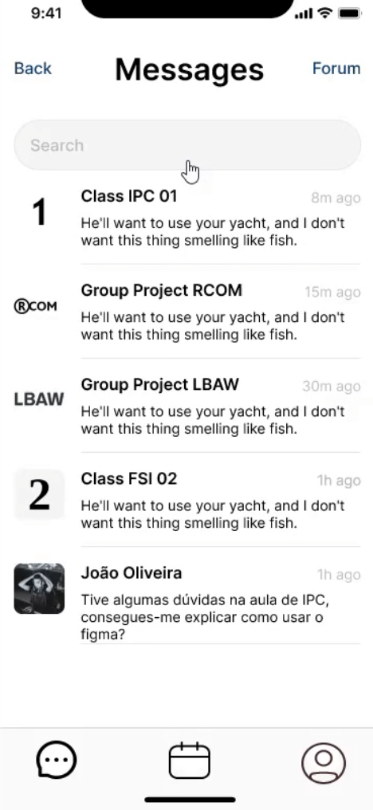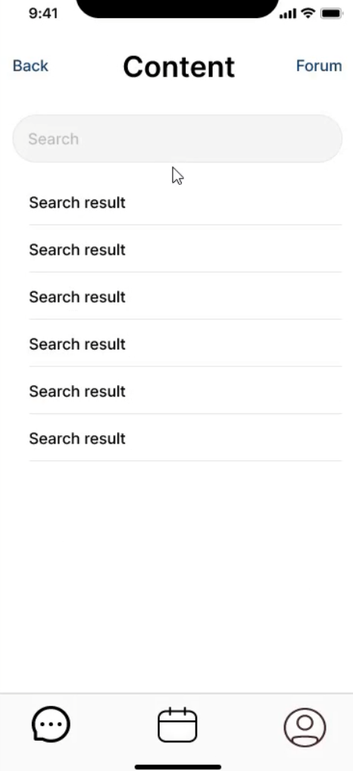



# Heuristic Evaluation Results

We were rated by groups 5 and 7 who gave us feedback on our app.

Group 5 identified that the bottom bar buttons did not show the correct page the user was on, which violates the visibility of system status heuristic. In addition, they recommended that we have a popup to confirm when the user wants to log out. Regarding this evaluation, we obtained a severity mean equal to 1.

On the other hand, we were also evaluated by group 7, which identified that the colors of the “Messages” menu are all dark and can quickly tire the user, which violates the aesthetic heuristic. Furthermore, they noted that the Forum button lacks the necessary evidence regarding its usefulness. This violates the efficiency of use heuristic. The group even went further and realized that there was no “Back” button on the “Events” page, as there was on other pages. This problem violates the user control and freedom heuristic. This same problem happened on the profile page, where we had a “Settings” button instead of a “Back” button which also violates the consistency and standards heuristic. After all this feedback, the severity mean we got from group 7 was 2.2.

# Corrections to perform in Phase 3

In order to improve our app, we should do the following improvements in the next phase:

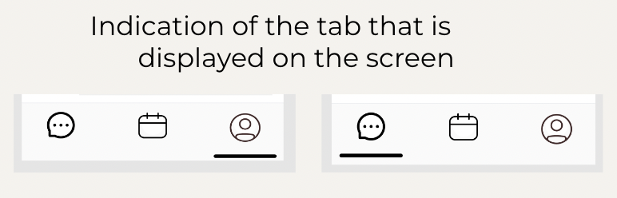

1. We should indicate the correct page where the user is in, doing it in the bottom bar buttons on our mobile app.

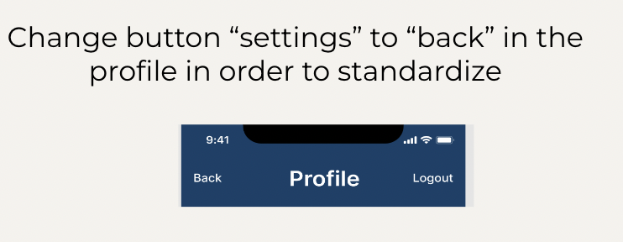

2. We should change the Settings button on the top left side of the page to the Back button so that we maintain the standard of use.

# 

1. We need to add the top side buttons on the Event page in order to facilitate the navigation in our app.

# 

4. We need to emphasize the forum button, since this is an important feature of our application.

# 

# 

5. We should include a pop up when the user is trying to logout of our application, in order to avoid errors and to maintain the user in our platform more time to help him.

# 

# 

6. We need to choose a more appealing color palette so we can transmit messages by them and so we avoid leaving the user in a boring state.

# Main Takeaways (Phase 2)

We realized through the evaluations on our application that we have some aspects to improve on color scheme, uniformizing the action buttons and displaying clear information about which screen the user is currently at for a better experience on the behalf of our users.

Nevertheless we concluded that our application was well achieved in terms of our objectives and its purpose. Finally with the corrections to be implemented in phase 3, UniChat would complete his intention on helping the academic community.

# Final Prototype’s Wireflow

[Link to the prototype](https://www.figma.com/file/4a0l50kQTuSAp25FR30k44/Mobile-UI?node-id=0%3A1&t=KNAKuTMAfCChEXp3-1)

## Send a message

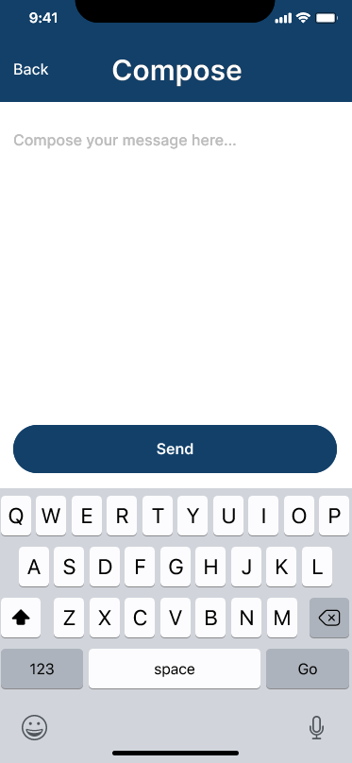

## Show interest in an event

## Search for query in messages

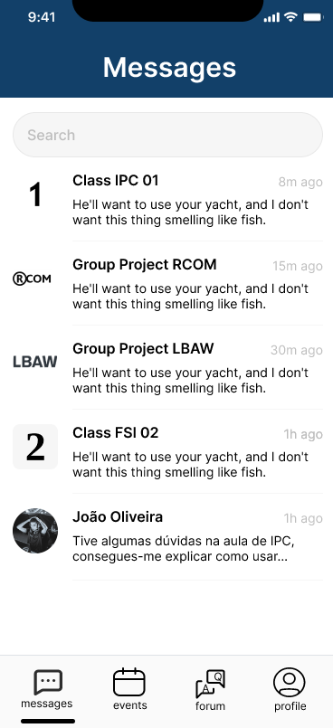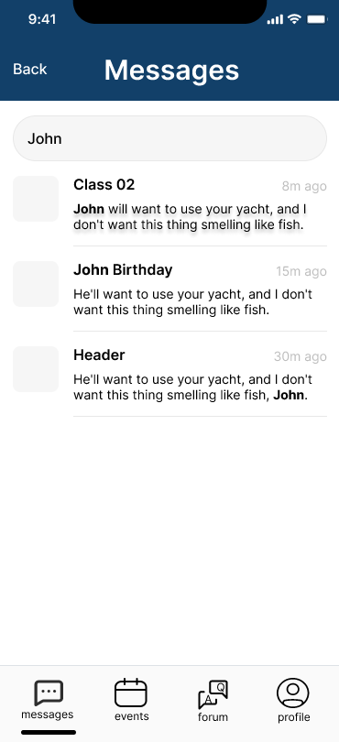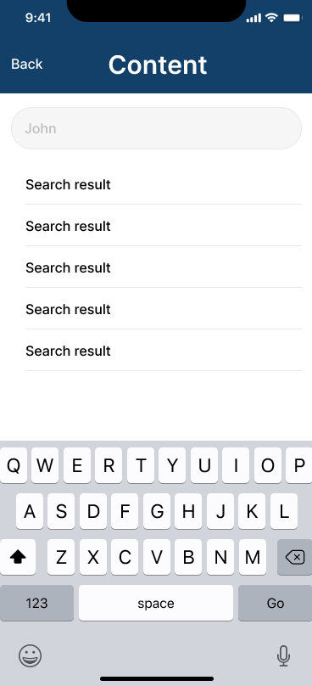

# 

# 

# 

# 

# 

# 

# 

# Evaluation Protocol

## Objective

UniChat is an app designed to give every student a better academic experience, allowing them to communicate with each other through messages or video calls, regarding subjects of the course and also find and show interest in events occurring in the university. Additionally there is a forum with topics that can be helpful to every student.

Each session has a 5 users sample, where all tasks will be performed between the groups. The participants will be guided on how to complete each task and will give a brief feedback on the application and its features.

## Users

Our customers are students, from University of Porto, with an age gap of 18-30. These students got their adolescence marked by the covid and the generation of the online classes. These undergraduates will be encountered in the aisles of FEUP, where we will communicate with them and introduce UniChat.

There should be a balance between genders, age and technical proficiency (from none experience to experienced users).

## Method

The evaluation protocol for this study involves recruiting volunteers to participate in testing the usability and design of an app. Participants will be informed that their participation is voluntary and that they can stop at any time if they are uncomfortable. All data collected will be anonymous.

During the evaluation, participants will be given a description of the app's goals and a brief guide on each feature. They will then be asked to perform tasks in a randomized order and their actions and responses will be recorded through direct observation and questionnaires.

The questionnaire will ask participants for their opinions on the relevance of each task, the intuitive nature of the app and its features, suggestions for improving usability, their thoughts on the design and layout, and any aspects of the app that they disliked.

This protocol is designed to gather feedback on the usability and design of the app to help improve its functionality and user experience.

## Tasks

1. Send a message (Claro que sim!...) to Colleague (João Oliveira)

The app should be open on the login screen.

Only needs to tap on letter C to auto complete the message to send.

1. Show interest in an event (FEUP Career Fair)

The app should be open on the messages screen.

1. Search for messages and contacts containing a query search (John)

The app should be open on the messages screen.

## Measures

We will record all sessions by logging.

### Data being collected

#### User Profiling

1. Age
2. Gender
3. Course
4. Technical proficiency
5. Regime

#### Task relative

1. Number of clicks for each task
2. Number of completed tasks
3. Time spent to complete the task
4. Hints needed to the user excel the task
5. Number of error clicks
6. Type of errors performed

#### Satisfaction

1. Satisfaction feedback from the user
2. Did the purpose of the app succeed
3. Which task was the favorite

# Results and statistical analysis

During the sessions, we collected data which allowed us to gain valuable insights after analyzing it.

Based on our observations, it appears that the task of "showing interest in an event" received the highest average number of clicks compared to the other tasks. It seems that all of the tasks performed well and met the expected values, as indicated by the graph.

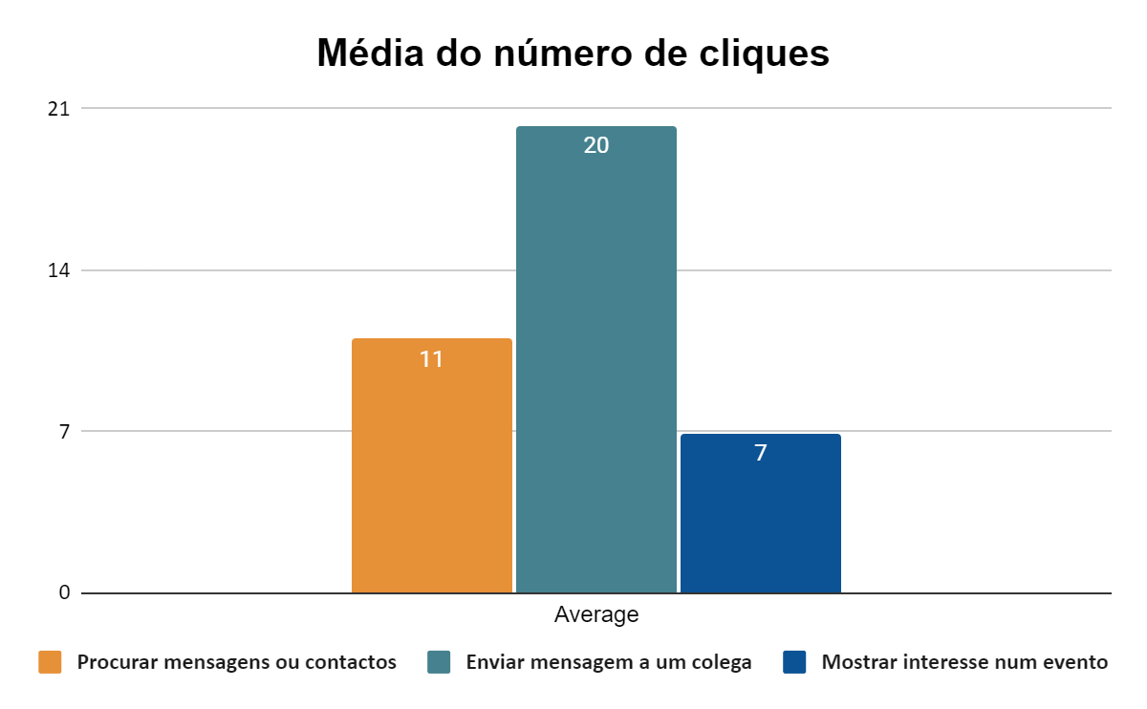

Figure 1. Average number of clicks per task

Based on the quartile graph, it appears that the task of "sending a message to a colleague" has a wide range of values, which may indicate that it is a more challenging task for users without technical knowledge. However, the other two tasks have a smaller range of values, indicating that the app is generally easy to use and accessible for all users.

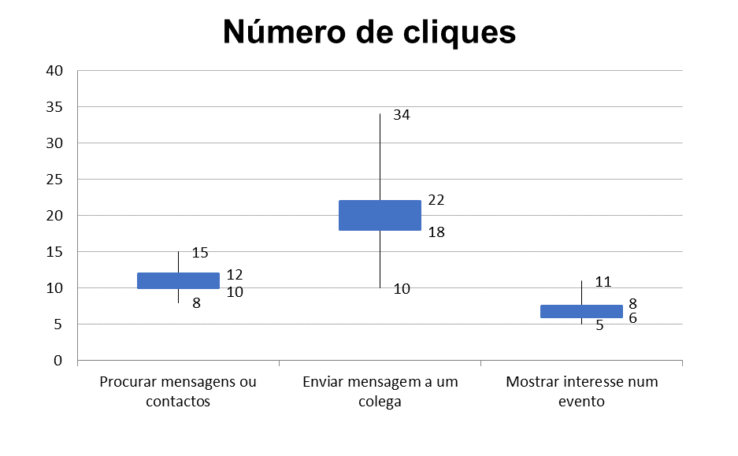

Figure 2. Range of clicks per task

According to the data collected, the task of "sending a message to a colleague" had the longest completion time, with a minimum of 20 seconds and a maximum of 67 seconds. The task of "showing interest in an event" had a shorter range of completion times, with a minimum of 8 seconds and a maximum of 15 seconds. The task of "searching for messages and contacts" had a range of completion times that was intermediate between the other two tasks, with a minimum of 10 seconds and a maximum of 24 seconds.

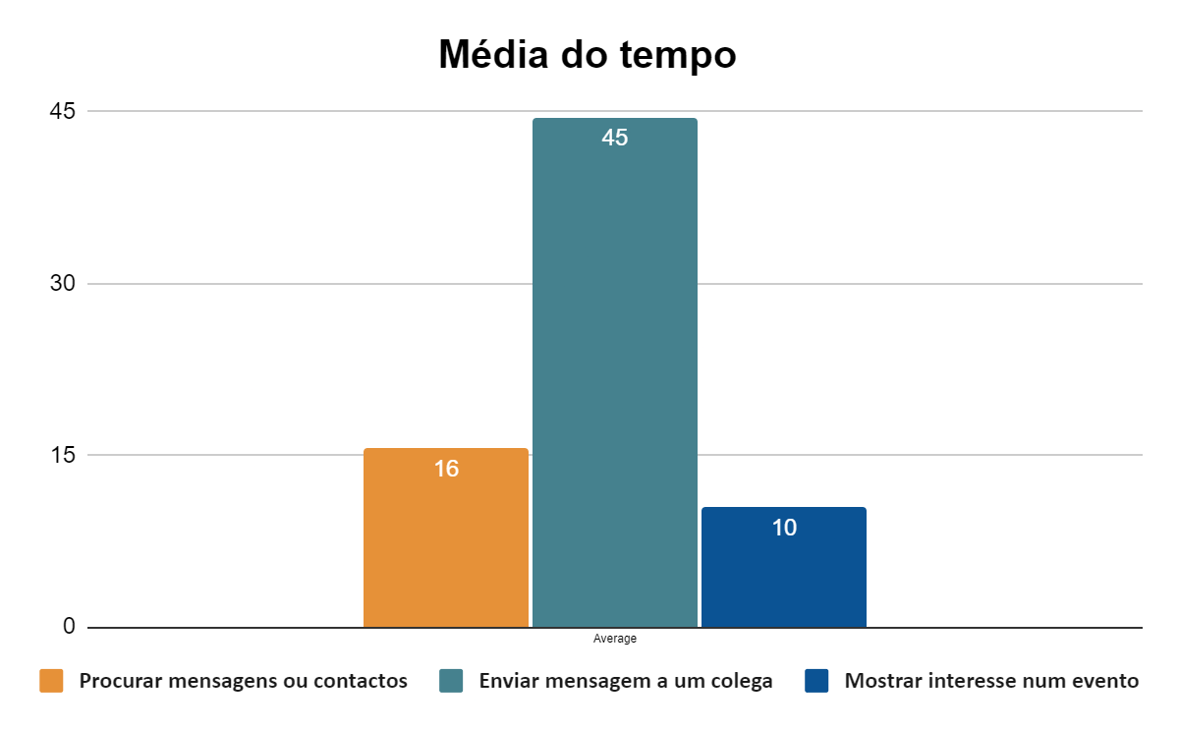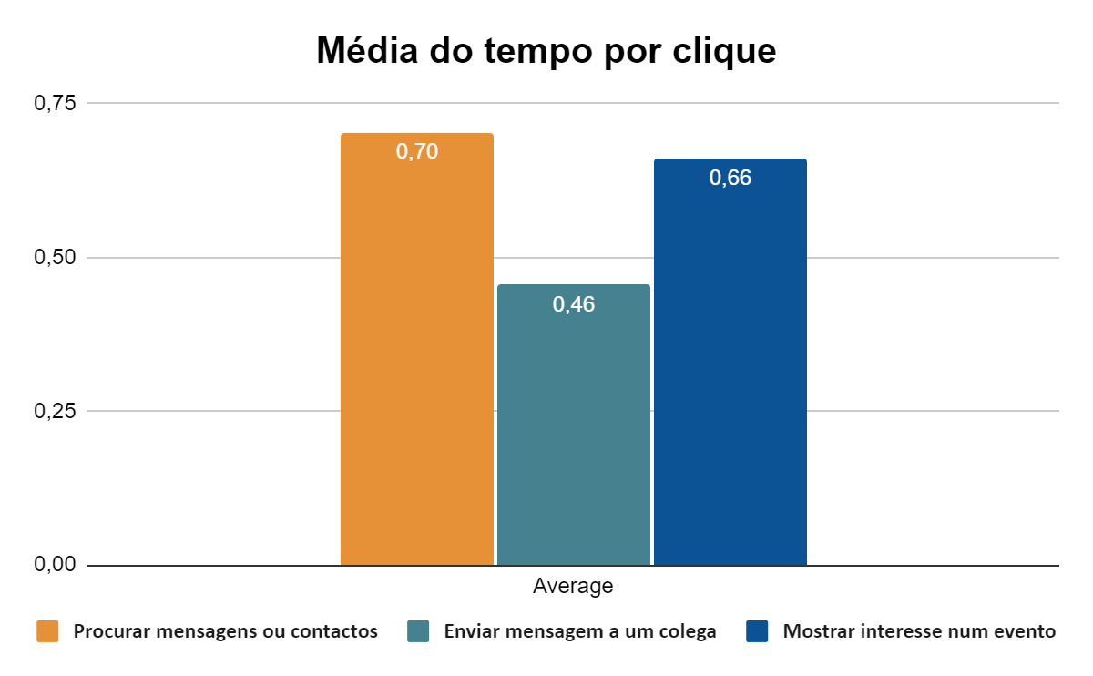

Figure 3. Average time of completion per task & Figure 4. Average time per click of completion by task

According to Figure 4, the average time per click is relatively similar between the three tasks, which suggests that they are equally easy to complete and the task “sending a message to colleagues” needs more clicks, that may be about the number of characters on the message to send.

To conclude our statistical analysis, we conducted t-tests on the data, as shown in Figures 14, 15, and 16.

We used a trust level of 5% for our hypothesis. When the test statistic t had a negative value, it indicated that the result exceeded our expectations, and the further the value was from 0, the better the performance.

In task 1, we were able to create an UI that allowed users to average below 20 clicks.

In task 2, the time spent was slightly lower than expected, with a result of 10 seconds compared to the expected 60 seconds.

In task 3, the task performance was consistent with expectations.

**More information about all statistics can be found at the end of the report.**

# Conclusions

The evaluation protocol for the app involved recruiting volunteers to participate in testing its usability and design. Participants were given a brief guide on each feature and asked to perform tasks in a randomized order. Their actions and responses were recorded through direct observation and questionnaires.

The measures collected during the evaluation included user profiling data (age, gender, course, technical proficiency, and regime), task-relative data (number of clicks, time spent, hints needed, errors made), and satisfaction feedback from the user.

In order to analyze the results of the evaluation, statistical analysis could be applied to the data collected for each task and measure. This allowed for the identification of patterns and trends in the data, and informed conclusions about the usability and design of the UniChat app.

Overall, the UniChat app was well-received by users, with high satisfaction ratings and relatively few errors made during task completion. There may be opportunities for improvement in the design and layout of the app, based on user feedback and the number of clicks and errors made during task completion.

We believe that UniChat will contribute significantly to improve the experience of students and their involvement in the community.

# Annexes

## Questionnaires

### Figure 5. Adaption difficulty

### 

### Figure 6. Success of academic cycle

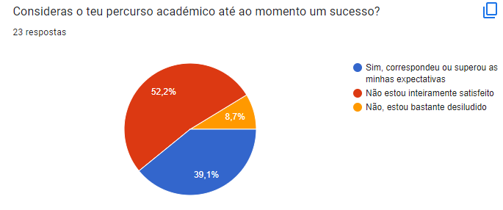

### Figure 7. Satisfaction with the course

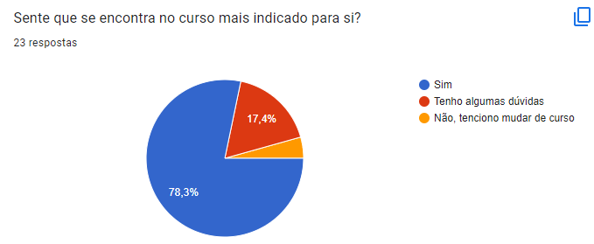

### Figure 8. What to do after finishing the bachelor

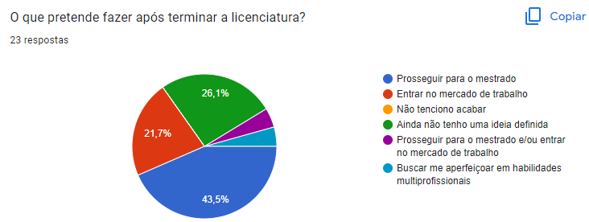

### Figure 9. Social media usage

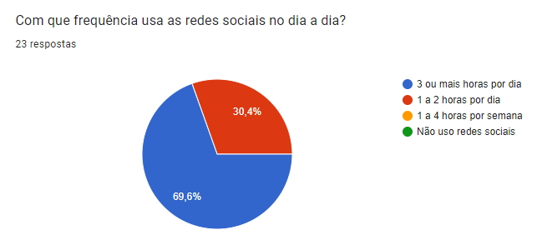

### 

### Figure 10. Adaptability of a new social media

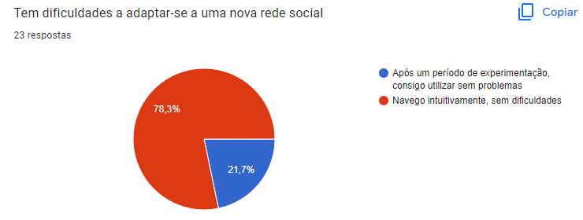

### Figure 11. Impact of social media

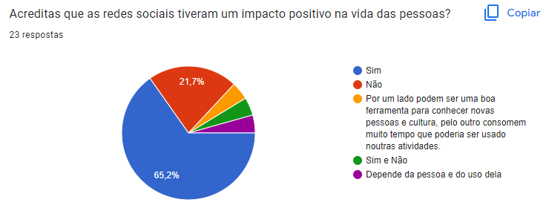

## Received Heuristic Evaluation Reports

### Group 5: [Heuristic Evaluation of Group 5](https://drive.google.com/file/d/1ksl8uVNAKG30P3xgsxPd9dY2vi-vYs4o/view?usp=sharing)

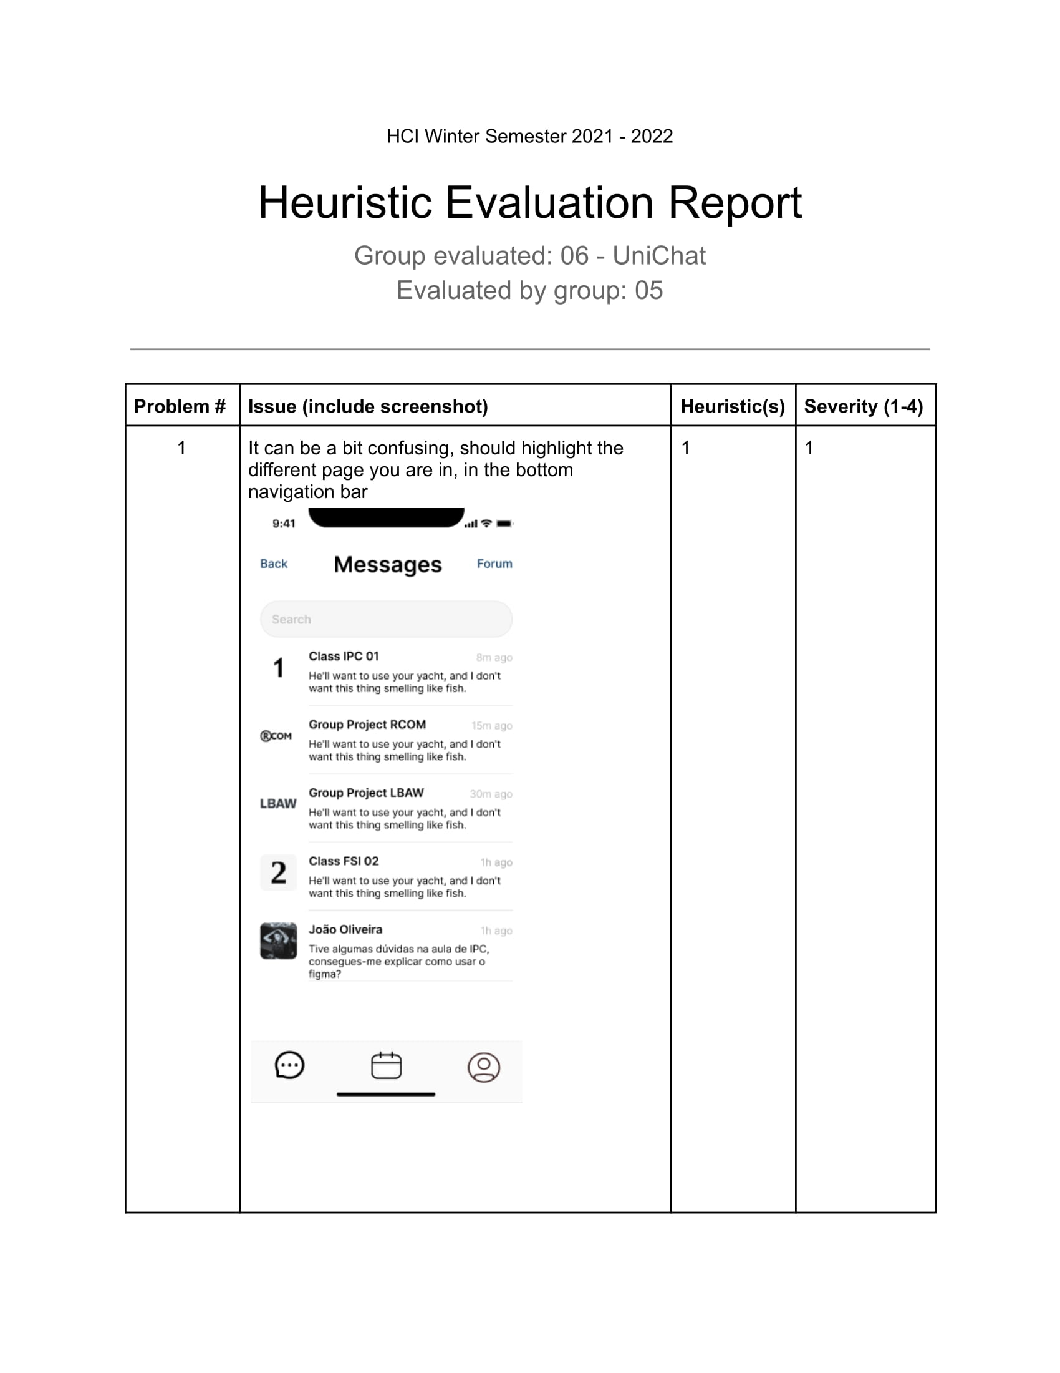

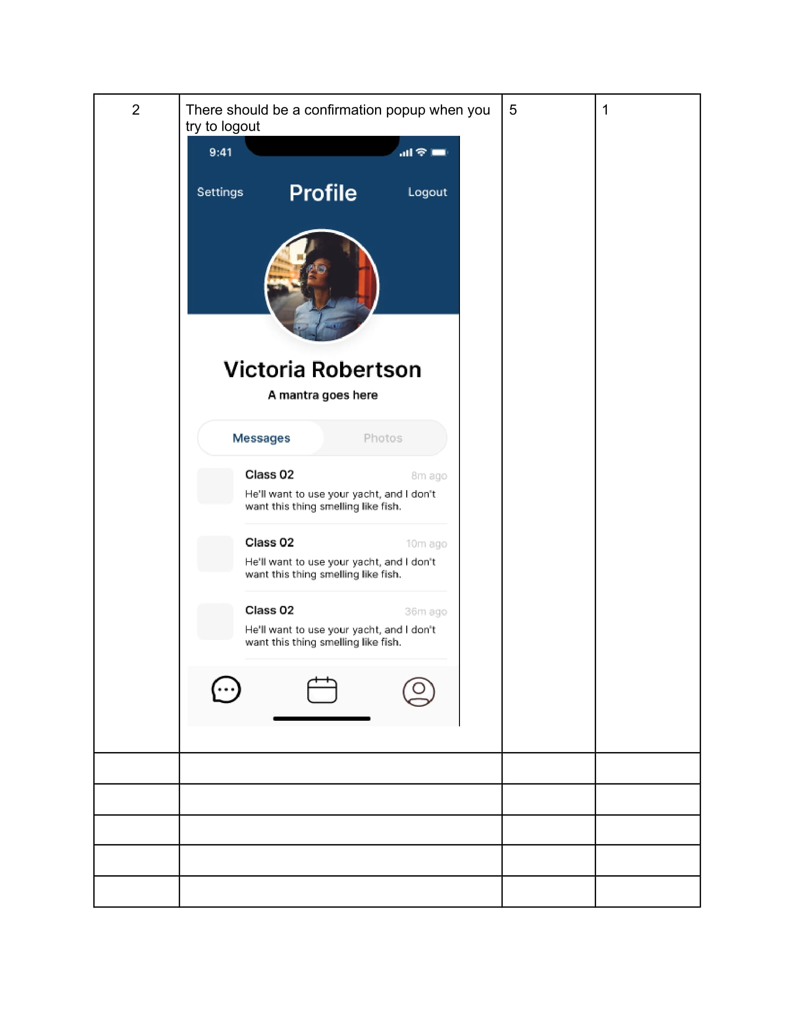

### Group 7: [Heuristic Evaluation of Group 7](https://drive.google.com/file/d/1e_IaqvL_1jbNoj744Oyuh-0LBgRb-q5a/view?usp=sharing)

## Statistics

### Figure 12. Users interviewed

| id | Age | Gender | Course | Technical proficiency | Regime |
| --- | --- | --- | --- | --- | --- |
| 1 | 22 | Male | Informática | Bom | Integral |
| 2 | 23 | Female | Arquitectura | Suficiente | Integral |
| 3 | 20 | Female | Engenharia Geoespacial | Insuficiente | Integral |
| 4 | 20 | Male | Informática | Bom | Integral |
| 5 | 20 | Male | Informática | Bom | Integral |
| 6 | 18 | Female | Mecânica | Suficiente | Integral |
| 7 | 19 | Female | Informática | Excelente | Trabalhador Estudante |
| 8 | 20 | Male | Gestão Industrial | Suficiente | Integral |
| 9 | 21 | Male | Química | Insuficiente | Trabalhador Estudante |
| 10 | 22 | Female | Bioengenharia | Bom | Integral |
| 11 | 18 | Male | Informática | Muito bom | Integral |

### Figure 13. Users responses on what most important on a university community app

| O que acha mais importante numa aplicação para a comunidade académica? | Códigos |
| --- | --- |
| Integração da aplicação com outros serviços da faculdade (cantina, biblioteca, etc) |  |
| Facilidade para os alunos utilizarem, mostrar eventos da faculdade |  |
| Mostrar oportunidades de estágio e de trabalho |  |
| Carregar saldo do cartão da uporto e usar na cantina |  |
| Oportunidades e eventos |  |
| Facilidade em comunicar com colegas |  |
| Informação sobre temas pertinentes relacionados com a faculdade |  |
| Comunicar com colegas de grupo em projetos |  |
| Obter informação sobre os locais de restauração |  |
| Informar sobre potenciais estágios e ofertas de trabalho |  |
|  |  |

### Figure 14. Task 1 data collected

|  | 1. Send a message (Claro que sim!...) to Colleague (João Oliveira) | | | | |
| --- | --- | --- | --- | --- | --- |
| id | Nº clicks | Time (sec) | Nº hints | Nº errors | Type of errors |
| 1 | 23 | 64 | 0 | 0 |  |
| 2 | 34 | 67 | 1 | 0 |  |
| 3 | 19 | 36 | 0 | 0 |  |
| 4 | 19 | 44 | 0 | 0 |  |
| 5 | 21 | 64 | 0 | 0 |  |
| 6 | 20 | 35 | 1 | 1 |  |
| 7 | 10 | 20 | 0 | 0 |  |
| 8 | 19 | 35 | 1 | 1 |  |
| 9 | 29 | 70 | 2 | 1 |  |
| 10 | 17 | 30 | 0 | 0 |  |
| 11 | 12 | 25 | 0 | 0 |  |
| Average | 20 | 45 | 0,45 | 0,27 |  |
| Standard Deviation | 6,80 | 18,33 | 0,69 | 0,47 |  |
| Variance | 46,22 | 336,07 | 0,47 | 0,22 |  |
| Sum of squared differences | 462,18 | 3360,73 | 4,73 | 2,18 |  |
| Median | 19 | 36 | 0 | 0 |  |
| Mode | 19 | 64 | 0 | 0 |  |
| 1st quartile | 18 | 32,5 | 0 | 0 |  |
| 3rd quartile | 22 | 64 | 1 | 0,5 |  |
| Test statistic t | -2,31 | 0,82 |  |  |  |
| Degrees of freedom | 10 | 10 |  |  |  |
| p-value | 0,04 | 0,43 |  |  |  |
| P-value (nivel de confiança 5%) | | | | | |
| (e.g. Número de cliques previstos era de 25, o p-value foi 0,04, menor que 5%. logo o número de cliques real é menos que 25) | | | | | |

### Figure 15. Task 2 data collected

|  | 2. Show interest in an event (FEUP Career Fair) | | | | |
| --- | --- | --- | --- | --- | --- |
| id | Nº clicks | Time | Nº hints | Nº errors | Type of errors |
| 1 | 7 | 10 | 0 | 0 |  |
| 2 | 6 | 9 | 0 | 0 |  |
| 3 | 5 | 12 | 0 | 0 |  |
| 4 | 6 | 9 | 0 | 0 |  |
| 5 | 7 | 13 | 0 | 0 |  |
| 6 | 8 | 10 | 0 | 0 |  |
| 7 | 5 | 8 | 0 | 0 |  |
| 8 | 8 | 10 | 0 | 0 |  |
| 9 | 11 | 15 | 1 | 0 |  |
| 10 | 7 | 10 | 0 | 0 |  |
| 11 | 6 | 9 | 0 | 0 |  |
| Average | 7 | 10 | 0,09 | 0 |  |
| Standard Deviation | 1,70 | 2,07 | 0,30 | 0 |  |
| Variance | 2,89 | 4,27 | 0,09 | 0 |  |
| Sum of squared differences | 28,91 | 42,73 | 0,91 | 0 |  |
| Median | 7 | 10 | 0 | 0 |  |
| Mode | 7 | 10 | 0 | 0 |  |
| 1st quartile | 6 | 9 | 0 | 0 |  |
| 3rd quartile | 7,5 | 11 | 0 | 0 |  |
| Test statistic t | -6,03 | -79,50 |  |  |  |
| Degrees of freedom | 10 | 10 |  |  |  |
| p-value | 0,00 | 0 |  |  |  |
| P-value (nivel de confiança 5%) | | | | | |
| (e.g. Número de cliques previstos era de 25, o p-value foi 0,04, menor que 5%. logo o número de cliques real é menos que 25) | | | | | |

### Figure 16. Task 3 data collected

|  | 3. Search for messages and contacts containing a query search (John) | | | | |
| --- | --- | --- | --- | --- | --- |
| id | Nº clicks | Time | Nº hints | Nº errors | Type of errors |
| 1 | 10 | 11 | 0 | 0 |  |
| 2 | 13 | 15 | 1 | 0 |  |
| 3 | 11 | 19 | 1 | 0 |  |
| 4 | 15 | 24 | 0 | 0 |  |
| 5 | 10 | 12 | 0 | 0 |  |
| 6 | 11 | 20 | 1 | 0 |  |
| 7 | 8 | 10 | 0 | 0 |  |
| 8 | 10 | 15 | 0 | 1 |  |
| 9 | 14 | 20 | 1 | 0 |  |
| 10 | 10 | 13 | 0 | 0 |  |
| 11 | 9 | 13 | 0 | 0 |  |
| Average | 11 | 16 | 0,36 | 0,09 |  |
| Standard Deviation | 2,14 | 4,48 | 0,50 | 0,30 |  |
| Variance | 4,60 | 20,05 | 0,25 | 0,09 |  |
| Sum of squared differences | 46,00 | 200,55 | 2,55 | 0,91 |  |
| Median | 10 | 15 | 0 | 0 |  |
| Mode | 10 | 15 | 0 | 0 |  |
| 1st quartile | 10 | 12,5 | 0 | 0 |  |
| 3rd quartile | 12 | 19,5 | 1 | 0 |  |
| Test statistic t | 1,55 | -10,64 |  |  |  |
| Degrees of freedom | 10 | 10 |  |  |  |
| p-value | 0,15 | 0,00 |  |  |  |
| P-value (nivel de confiança 5%) | | | | | |
| (e.g. Número de cliques previstos era de 25, o p-value foi 0,04, menor que 5%. logo o número de cliques real é menos que 25) | | | | | |